Embedded Night-Vision System for Pedestrian Detection

Now a days with advance technologies drivers may get lots of information from sensors such as upcoming traffic signals, diversions, traffic conditions and many more information but this sensors may not provide accurate information about pedestrian or any other objects at night due to darkness or low quality cameras. To overcome from this problem author is evaluating performance of YOLOV2 CNN (convolution neural networks) object detection model but this model also unable to detect objects from NIGHT VISION.

In propose work to detect objects from NIGHT VISION author using HAAR HOG descriptor with ADABOOST algorithm and this algorithm providing better detection compare to YOLOV2 and its false detection rate is also less. This algorithm will clear the image using OPENCV and ADABOOST and then apply HAAR HOG features to detect pedestrian in that image.

In propose work I am using 6 night vision images and YOLOV2 able to detect pedestrian from 4 images and ADABOOST able to detect pedestrian from all 6 images but it is detecting some false images also as pedestrian due to this reason ADABOOST detection accuracy will be 80% and YOLOV2 detection accuracy will be 4/6 = 0.66.

ADABOOST detection rate = 6/6 \* 100 = 100% - 20 (for false detection rate) = 80%

YOLOV2 = 4/6 \* 100 = 66%

To test above 2 algorithms I am using below NIGHT VISION images

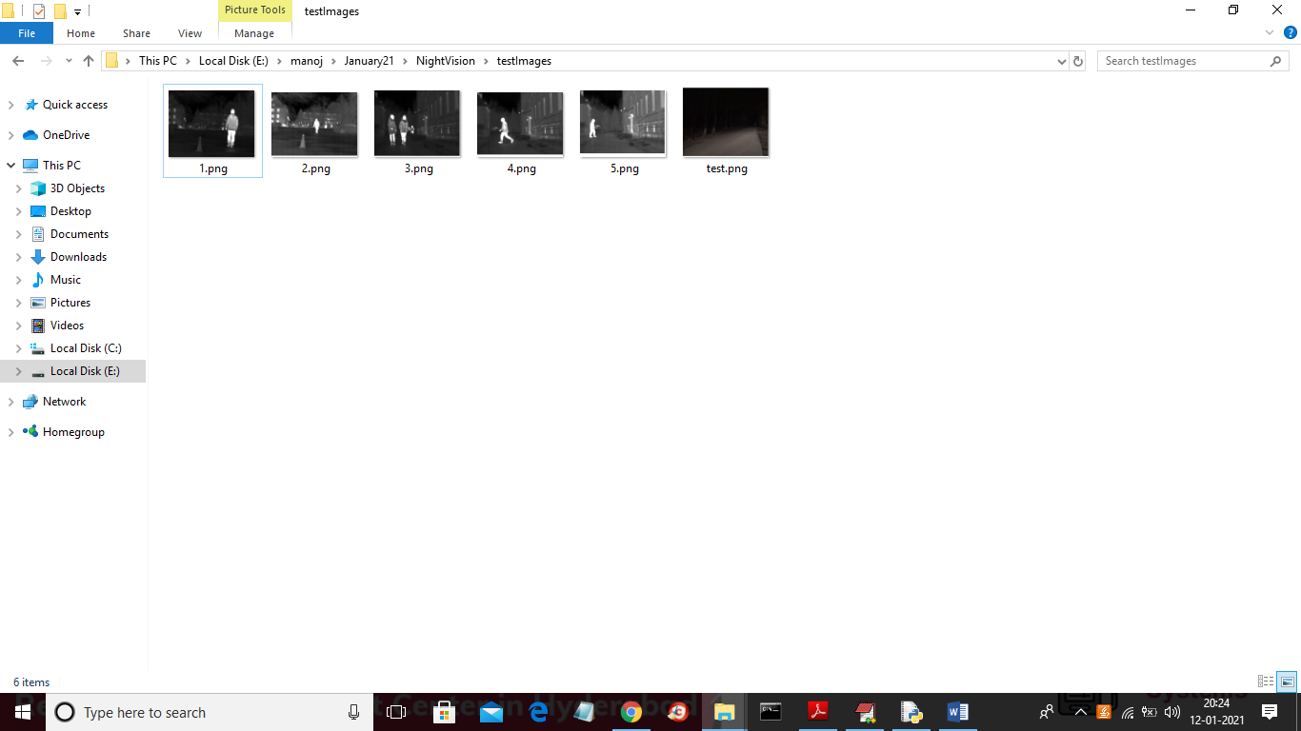

In last image we can see we are unable to see any pedestrian but ADABOOST can detect it.

To run project double click on ‘run.bat’ file to get below screen

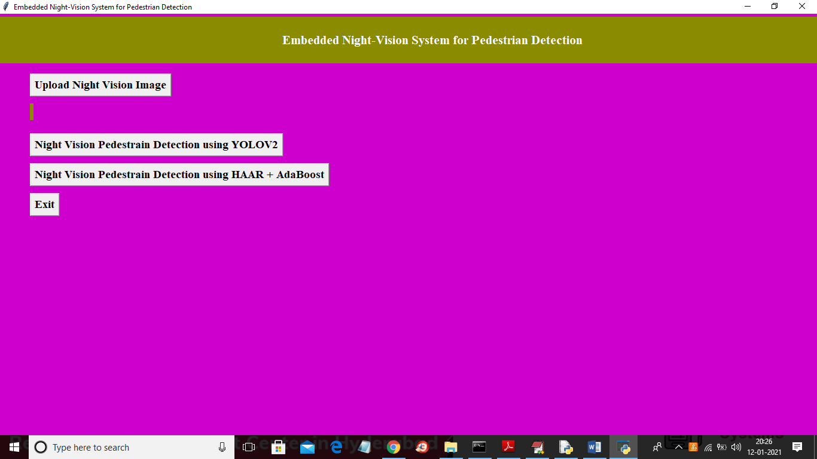

In above screen click on ‘Upload Night Vision Image’ button and upload image

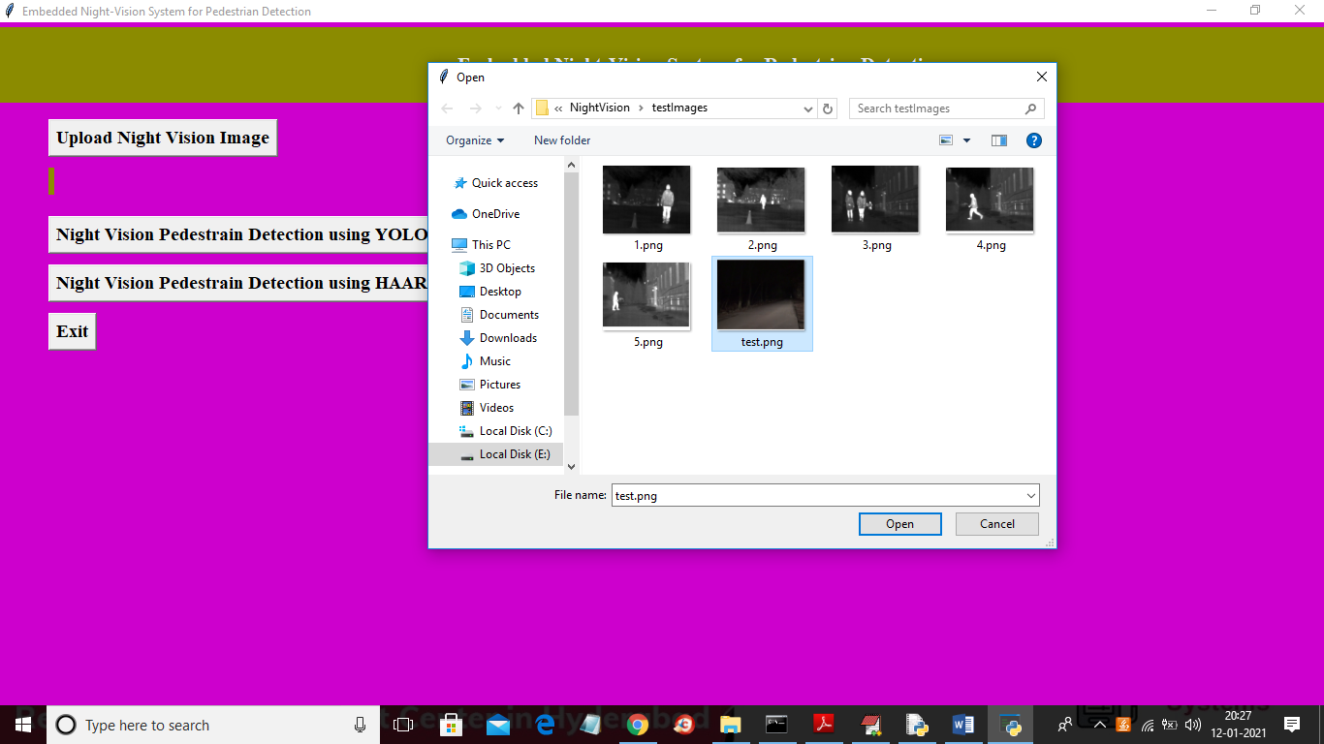

In above screen I am selecting ‘test.png’ image and then click on ‘Open’ button to load image and to get below screen

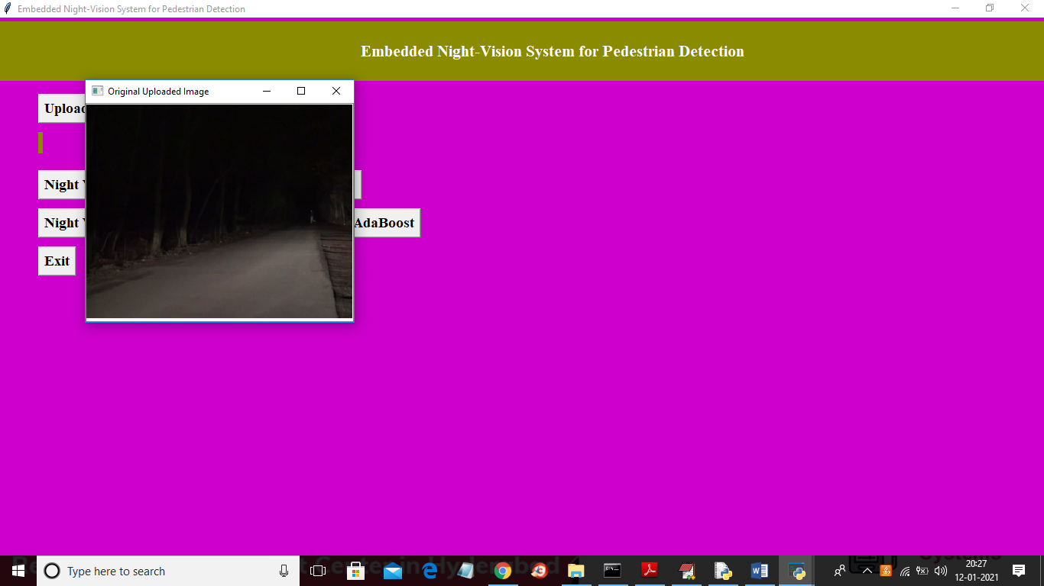

In above screen showing uploaded original image and hardly we can see the pedestrian and now try to detect that pedestrian using YOLOV2 algorithm by clicking on ‘Night Vision Pedestrian Detection using YOLOV2’ button

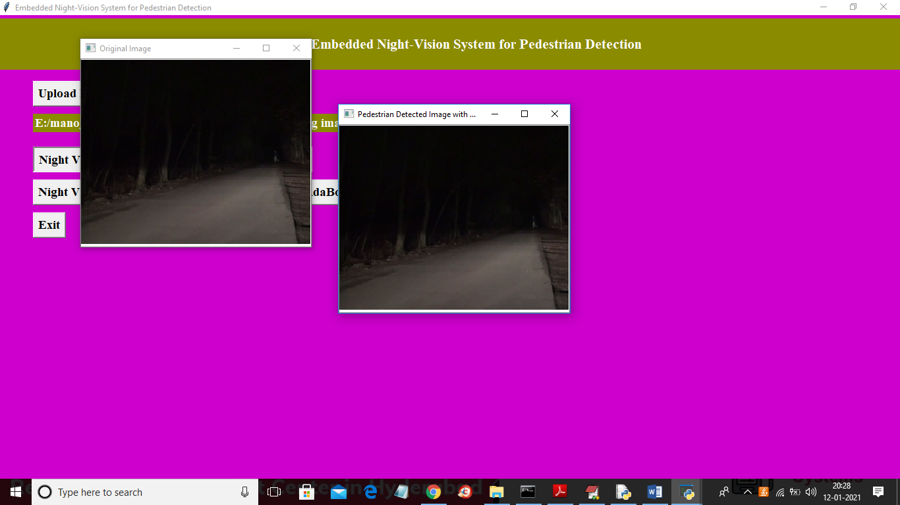

In above screen first image is the original image and second image is the YOLOV2 resultant image and in second image we did not find any bounding box across pedestrian so YOLOV2 unable to detect that pedestrian and now click on ‘Night Vision Pedestrian Detection using HAAR + AdaBoost’ button to get below result

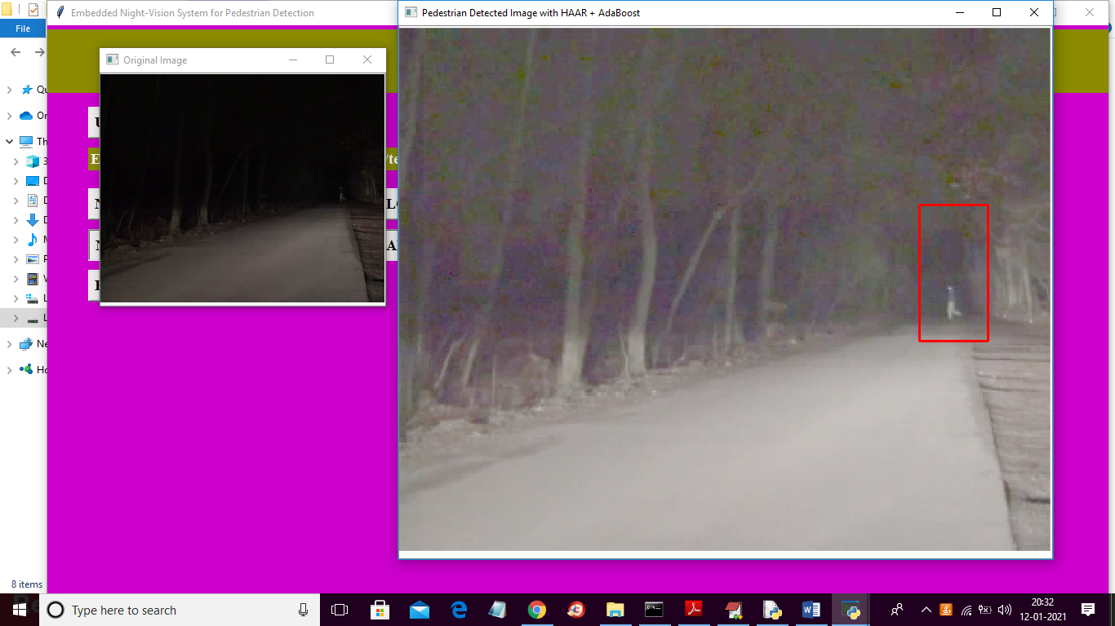

In above screen first image is the original image and second image is the resultant image from HAAR + ADABOOST algorithm and this algorithm able to detect pedestrian successfully and putting bounding box across detected pedestrian.

Now test with other image

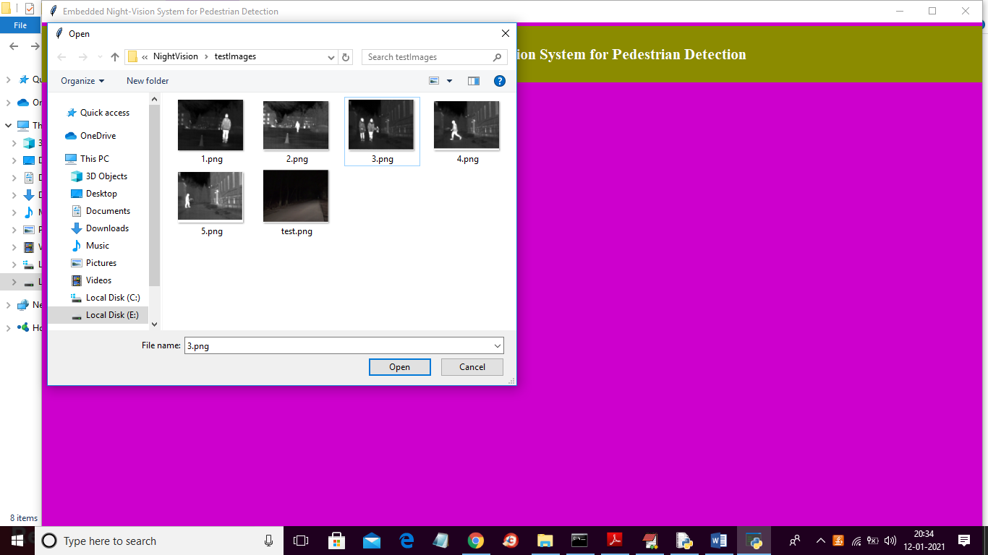

In above screen uploading 3.png and then below is the YOLOV2 result

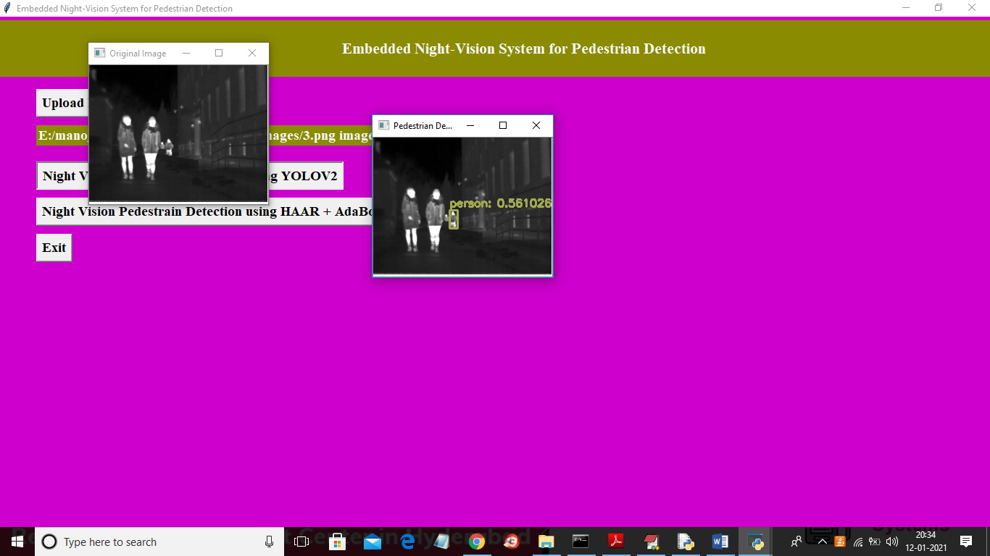

In above image YOLOV2 able to detect the persons and now test with ADABOOST

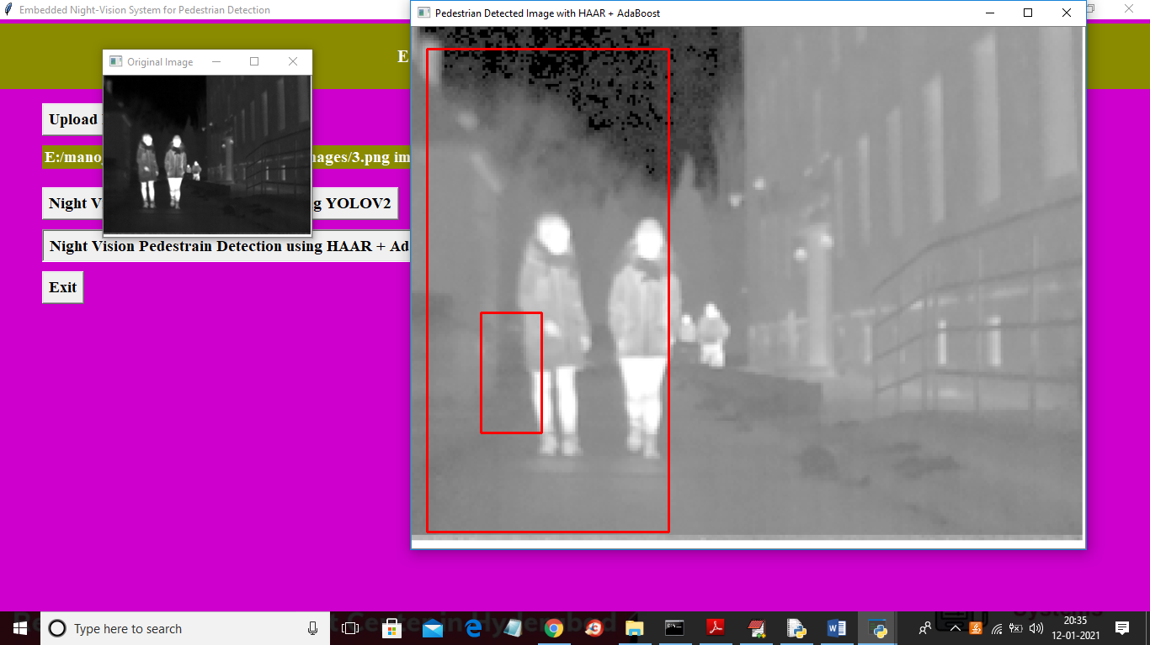

In above screen we can see ADABOOST detecting both persons accurately. Similarly you can upload other images and test the application